**PROJECTDEVELOPMENTPHASE**

**DELIVERY OF SPRINT 1**

|  |  |
| --- | --- |
| Date | 17 November 2022 |
| Team ID | PNT2022TMID50604 |
| Project Name | Project – Personal Assistance for senior citizens who are self-reliant |

1. Launch IBM Watson IoT Platform

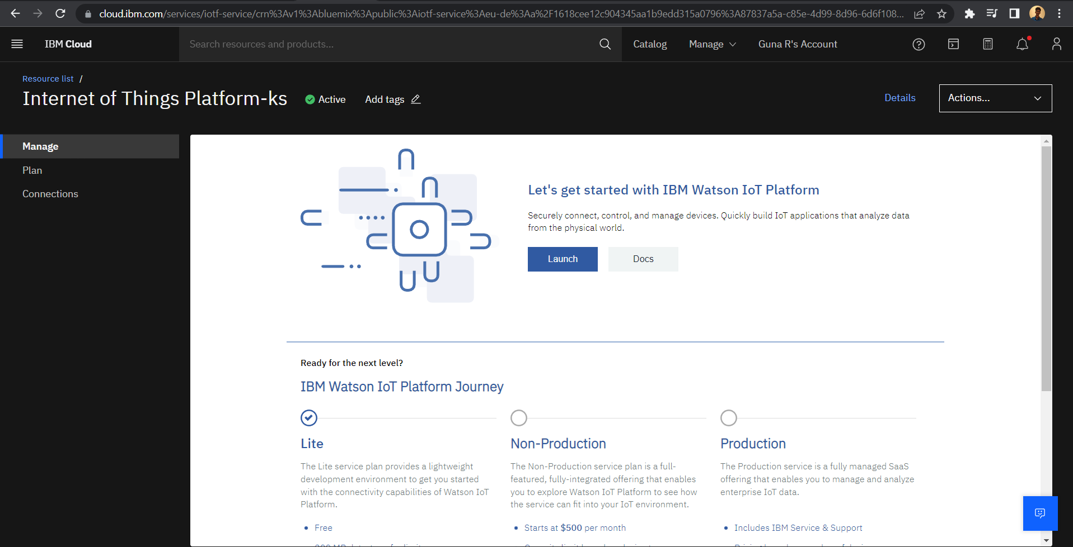

1. Creation of Cloudant DB

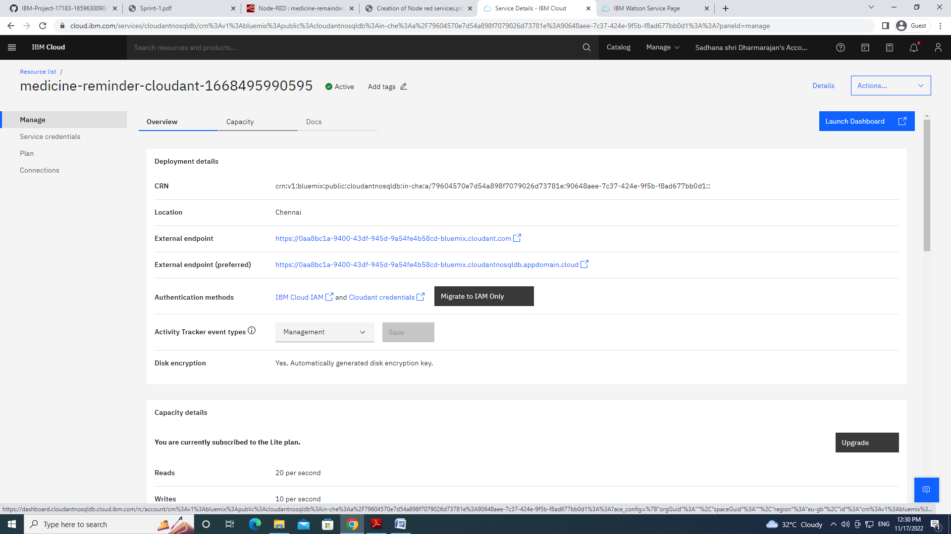

1. Node red service :

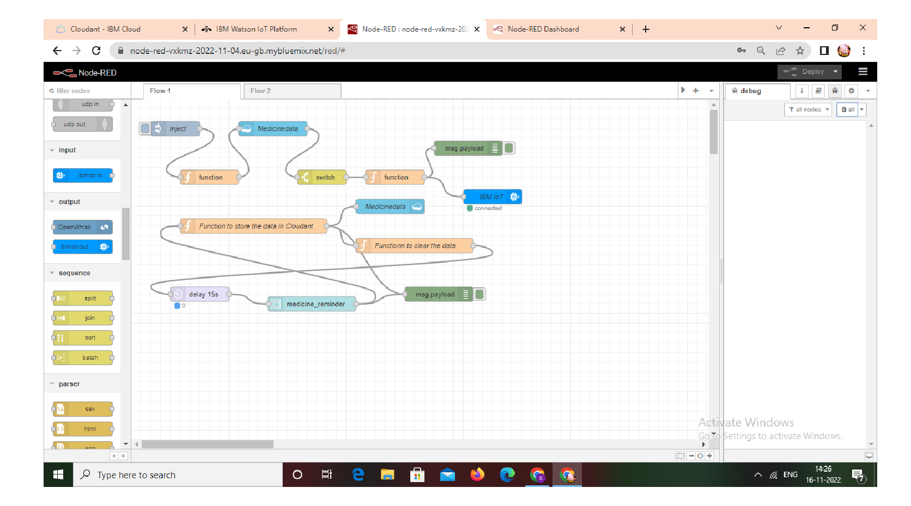

1. Text to speech service :

